# EX 12 - PL/SQL TRIGGERS

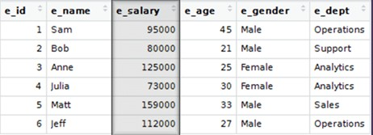

1. Create a row-level trigger for the EMPLOYEE table that would get executed by the DML statement like UPDATE OR INSERT on that table.
2. The trigger will compute and show the SALARY difference between current and previous values.(Hint: previous salary: , current salary: , salary difference: )

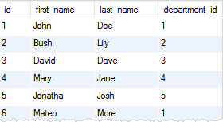

1. Create a trigger for the STUDENT table that would get executed by the DML statement like UPDATE OR INSERT on that table.
2. The trigger will compute and show the message “Department does not exist if the department_ id is greater than 5”.

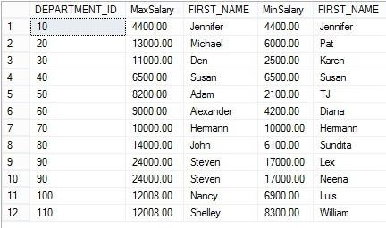

1. Create a trigger for the EMPLOYEE table that would get executed by the DML statement like UPDATE OR INSERT on that table.
2. The trigger will compute and show the difference between the min salary and max salary.